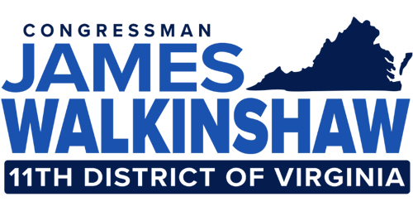
Youth Leadership Council Consent Form

Name of Student:
Student Phone Number:
Name of Parent:
Parent/Guardian Phone Number:

I consent for my child (name) _______________________ to participate in the Congressional Youth Leadership Council program. I, the undersigned, expressly release the Office of Congressman James Walkinshaw, and any of its members and staff, any participating public official, or any other participating agency/ organization from any and all claims which may arise during the term of my child’s membership, if he/she is selected. I consent and agree that photographs and/or video/audio recordings may be taken of my child’s participation in this program.

I consent that the Office of Congressman James Walkinshaw may use any such photographs or recordings for educational and/or promotional materials. I further consent that my child’s name may be revealed in such materials by descriptive text or community. I hereby release to the Youth Leadership Council all rights to exhibit this work publicly or privately, including posting it on the Congressman’s website and associated social media platforms. I waive any rights, claims, or interests I may have to control the use of my child’s identity or likeness in photographs, video, or audio recordings, and agree that any uses described herein may be made without compensation or additional consideration

Parent/Guardian Signature: ________________________ Date______________

